

**Computer Programming Lab**

Assignment no 1

Submitted by:

**Shah Jahan khan**

**469192 (section C)**

Submitted to:

**Sir Affan Tariq**

**Manuel 1**

**lab tasks**

**1.** Write a C++ code that displays your name, department and degree on the console. Make sure the three things are in three different lines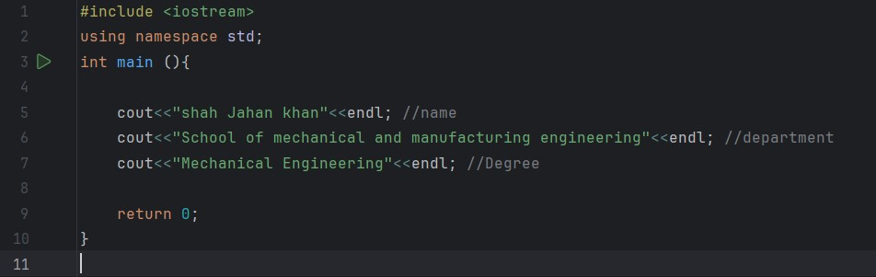

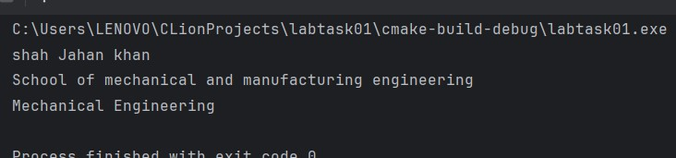

2. Write a C++ code that takes two numbers and displays the addition, subtraction, division, multiplication and square of given numbers, on the console window. Make sure to comment your code.

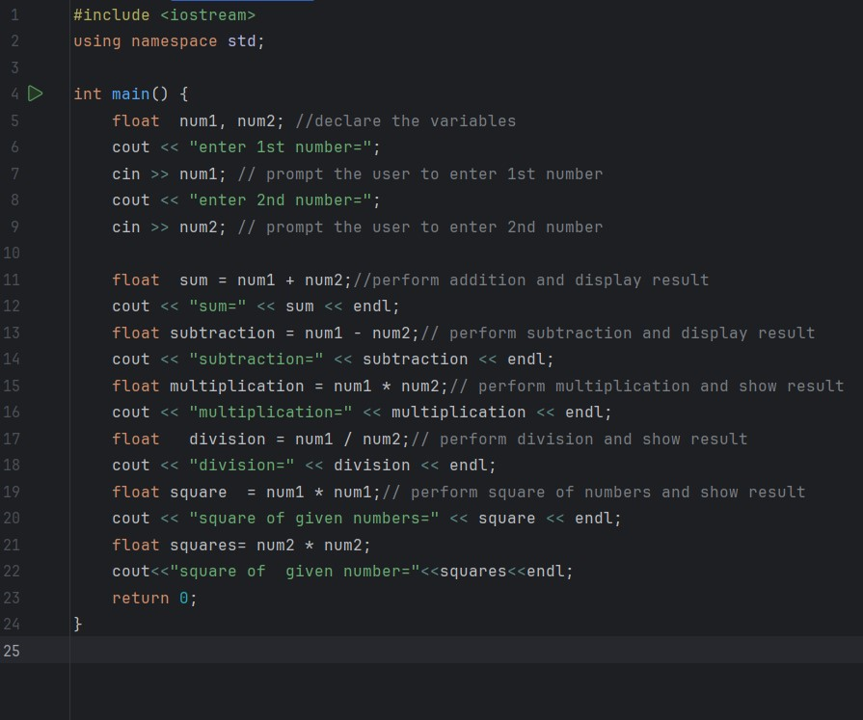

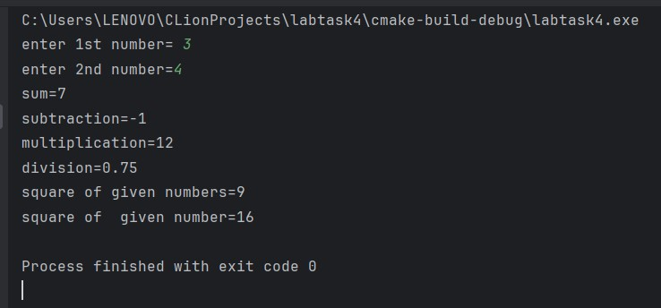

3. Write a code in C++ that takes radius of a circle as input from user and outputs the circumference and area. The output should be clear and readable. Add proper comments to the code. You can set the value of π up to 3 decimal places.

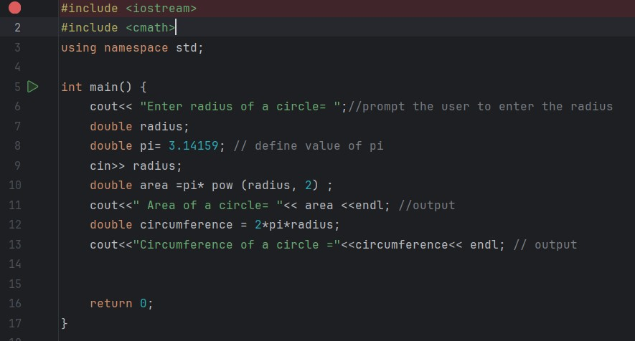

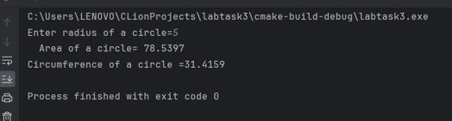

4. Write a C++ code that prints out the following sequence: 0, 1, 1, 2, 3, 5, 8, 13 using three variables.

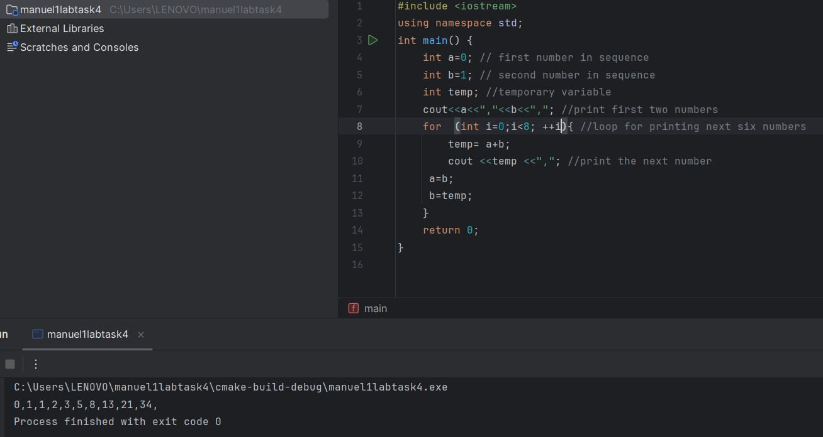

**Home tasks**

1. Write a C++ program to calculate distance between two points. The values of coordinates should be input by user.

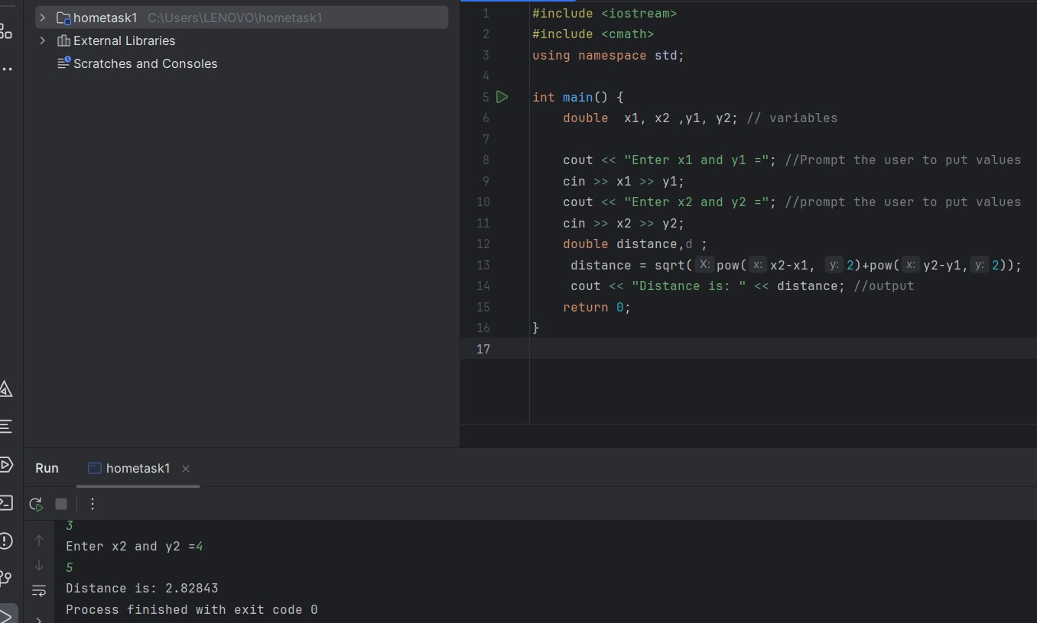

1. Write a code in C++ to take length from user in centimetre and convert it into meter and kilometre.

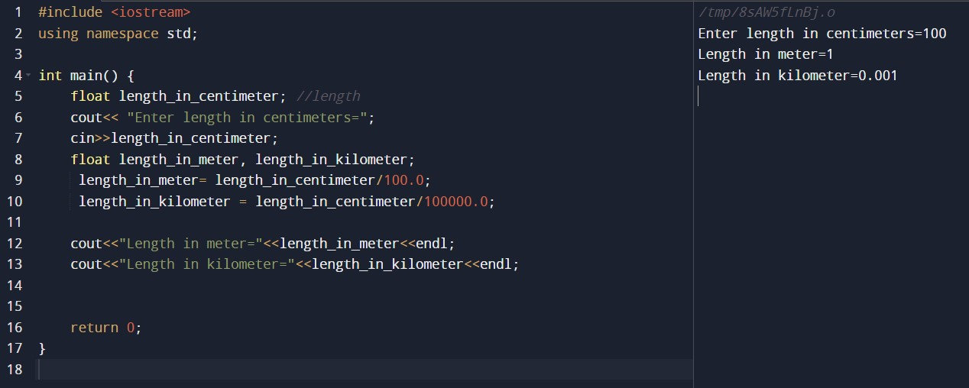

3. Write a code in C++ that takes values of a and b from the user and displays result of polynomial 𝑎 2 + 2𝑎𝑏 + 𝑏 2. 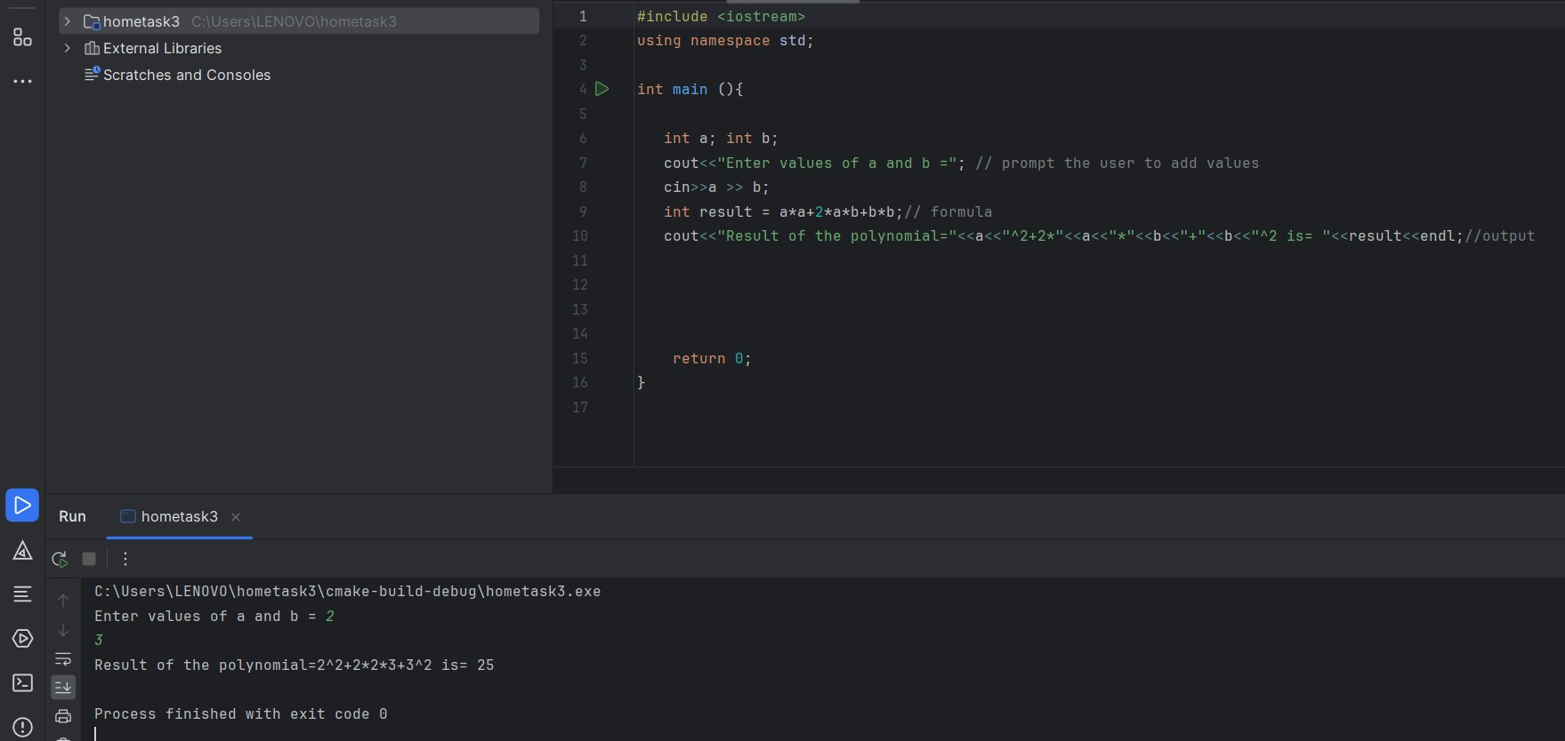

4. Write a program in C++ to convert temperature in Fahrenheit to Celsius.

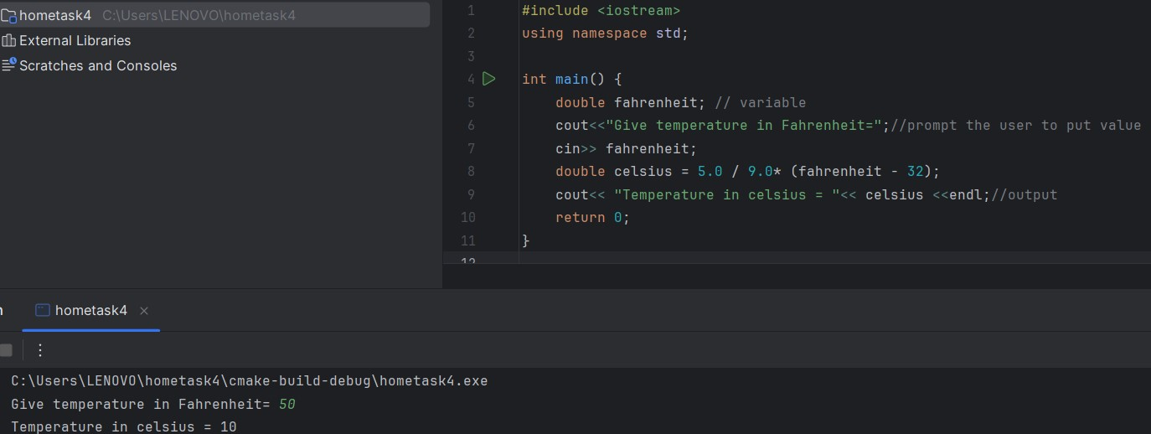

Manuel 2

Lab tasks

1. Write a program that determines if a person is eligible to vote based on their age (e.g., 18 years or older) using logical operators.

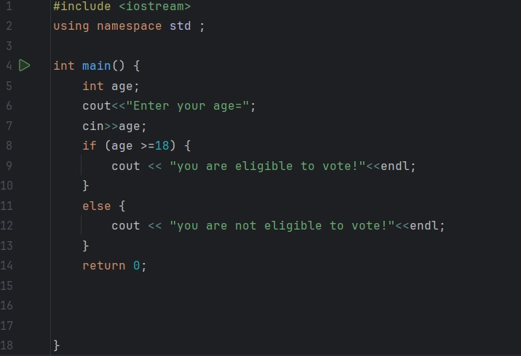

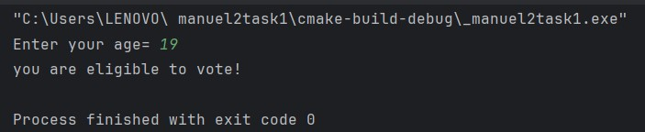

1. Write a program that takes an integer as input and checks if it falls within the range [10, 50] using logical

Operators.

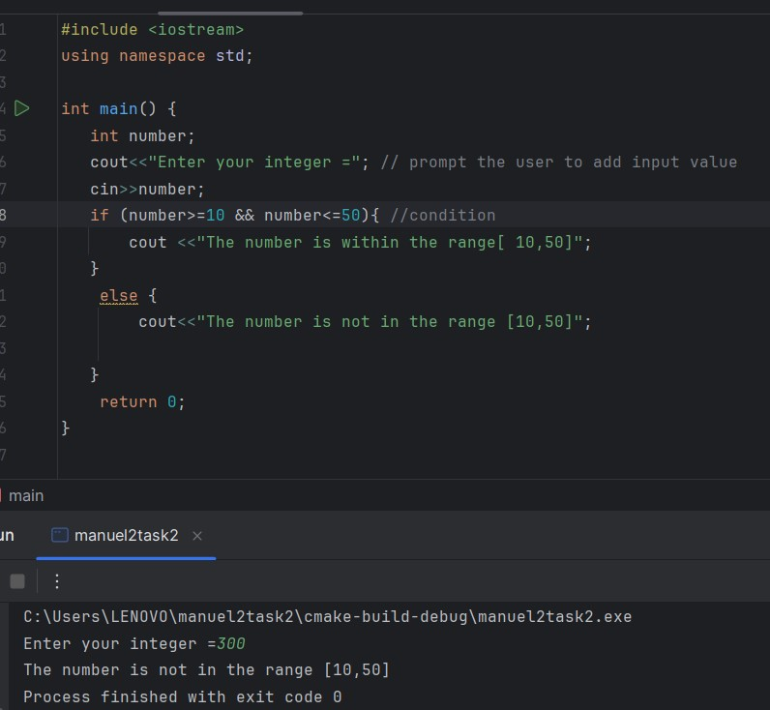

1. Write a C++ program to compare two integers and find the maximum value.

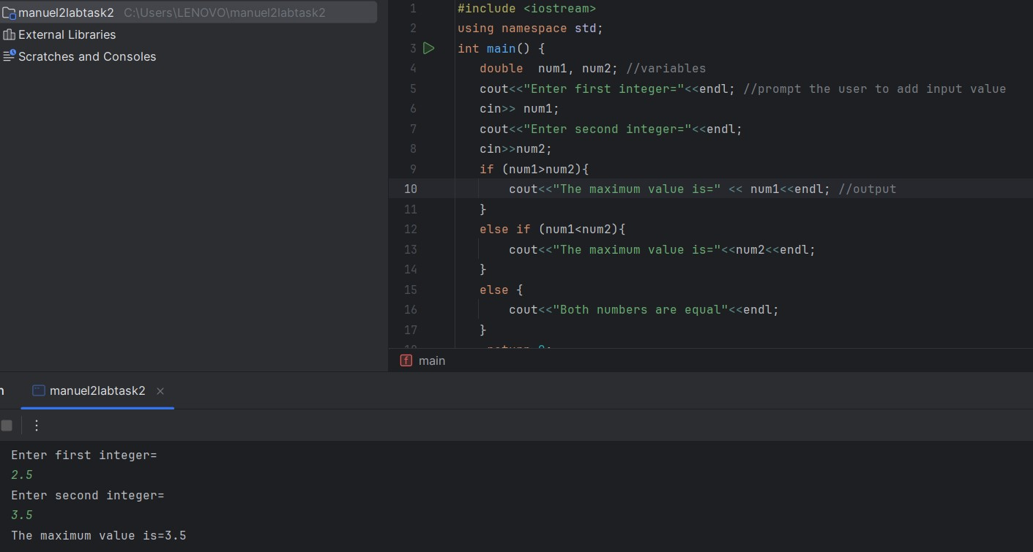

1. Write a C++ program to calculate the average of three exam scores and determine if it's above a passing grade (e.g., average >= 60).

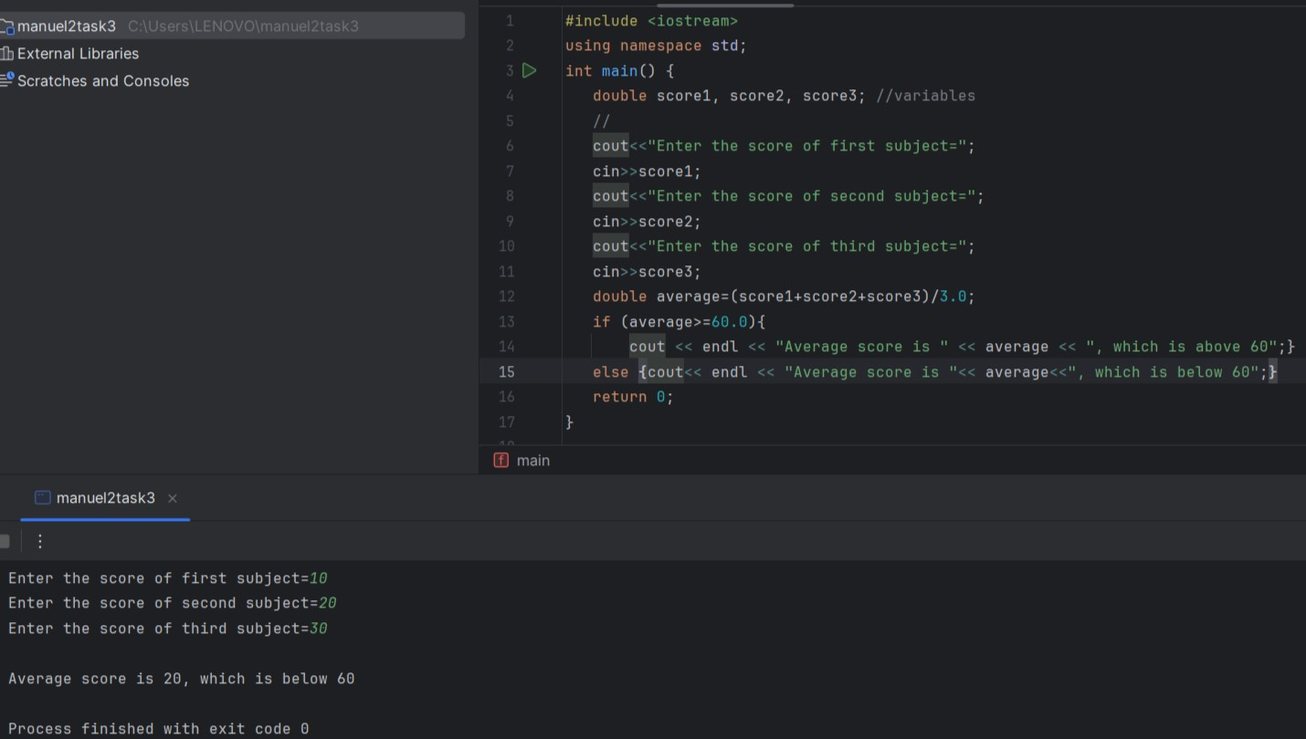

**Home Tasks**

1. . Create a program that takes a student's score as input and assigns a grade based on predefined criteria using logical operators (e.g., A, B, C, D, F). A-Grade: 90-100 Marks B-Grade: 75-90 Marks C-Grade: 60-75 Marks D-Grade: 45-60 Marks F-Grade: 0-45 Marks.

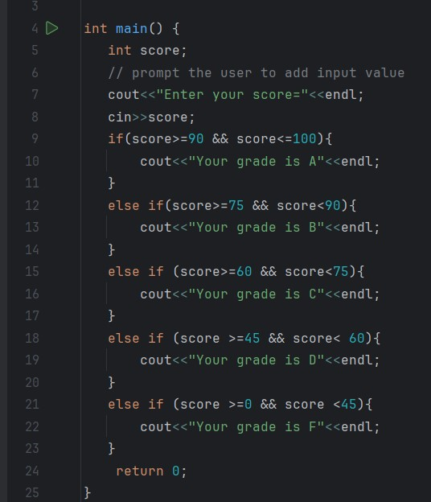

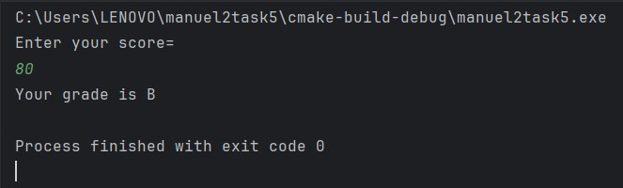

2. Write a program that takes an integer as input and determines if it is both even and divisible by 5.

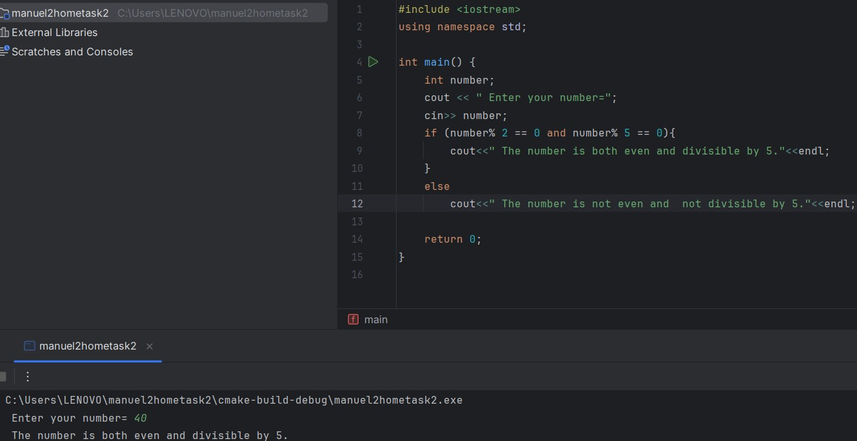

1. Create a C++ program that checks if a user-provided year is a leap year.

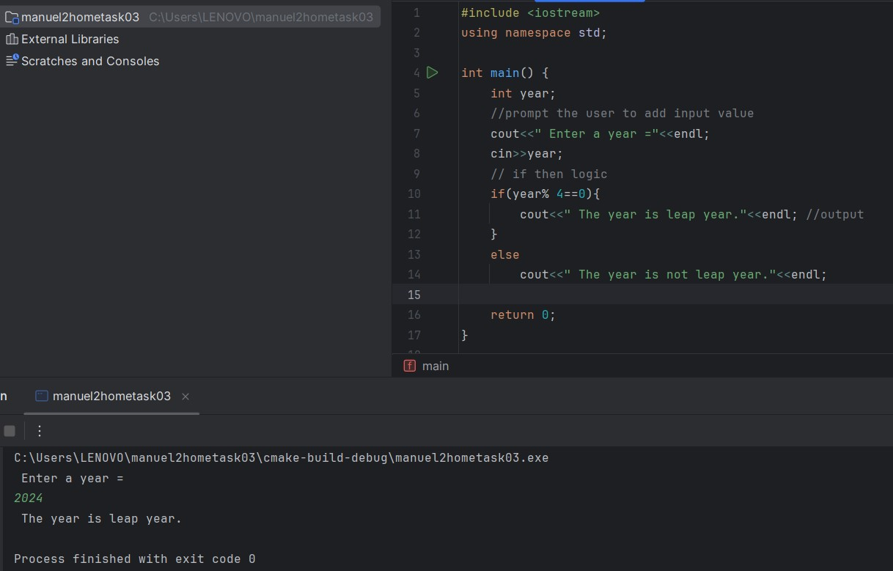

1. Create a C++ program that determines if a student is eligible for a scholarship based on their GPA (must have GPA >= 3.5) and attendance (must have attended at least 80% of classes).

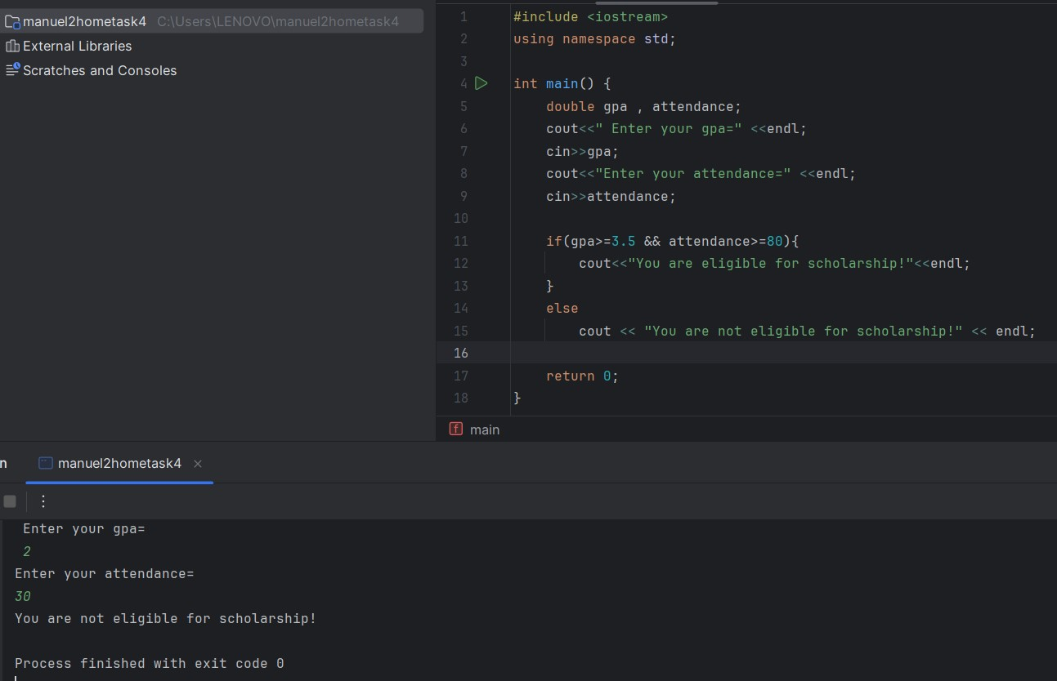

1. Write a program that checks if a given character is a vowel (a, e, I, o, u) or a consonant using logical operators.

